**Lab – 11: Set up Azure Active Directory joined devices.**

**Objective:** The objective of this lab is –

* To set up Azure Active Directory joined devices.

If you want to bring work-owned Windows 10 devices under the control of Azure AD, you can accomplish this by configuring Azure AD joined devices. In this lab, we are going to add Windows 10 device under Azure AD.

Note: To join a Windows 10 device, the device registration service must be configured to enable you to register devices.

**Prerequisite:** EMS Enterprise Mobility + Security E5 and Windows 10.

**Steps:**

1. Sign in to your Azure Portal, by using the link - **https://portal.azure.com/**. Enter your credentials and click Sign In.

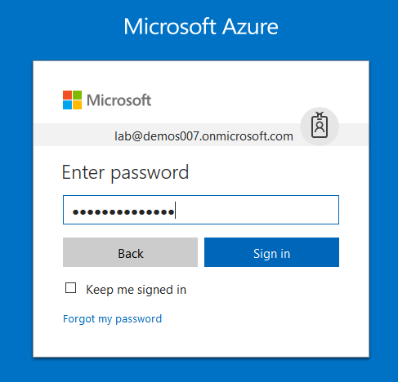

1. Microsoft Azure AD Dashboard will open.

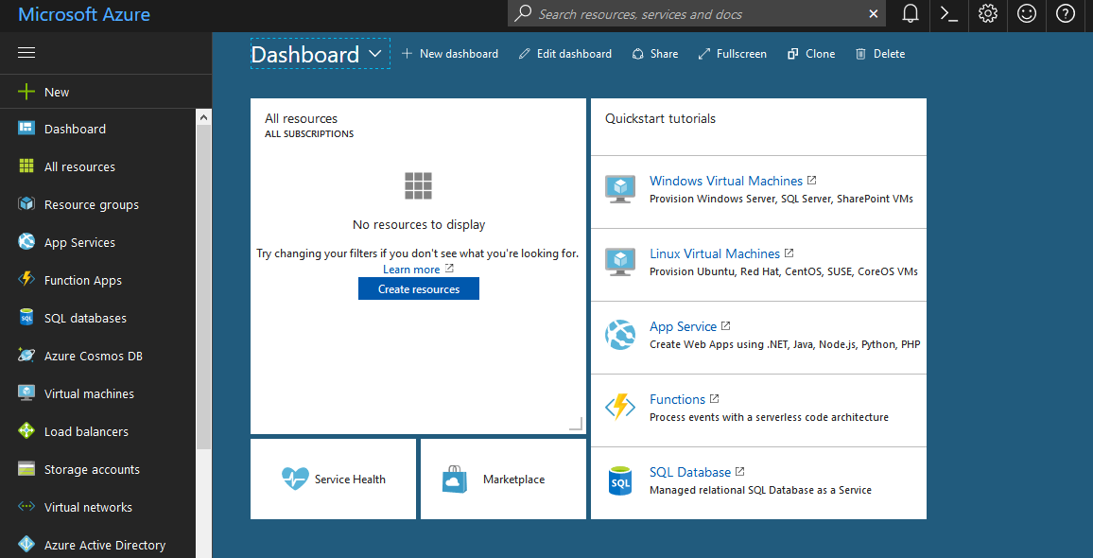

1. Now click **Azure Active Directory** from left-hand pane, and then select **Devices (preview)** in the **Manage** section.

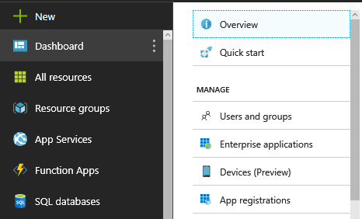

1. Here you can see all the registered devices with your Azure AD.
2. Now let’s join a new Windows 10 device. For this, log in to Windows 10 with Administrator Privileges. Then in the **Start** menu, click **Settings**.

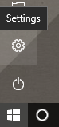

1. Click **Accounts**.

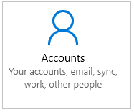

1. Click **Access work or school**.

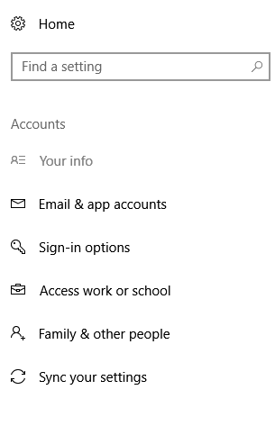

1. On the **Access work or school** dialog, click **Connect**.

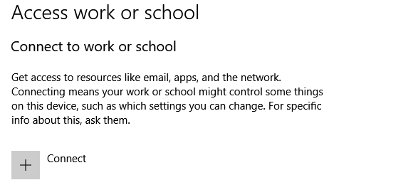

1. On the **Setup a work or school account** dialog, click **Join this device to Azure Active Directory**.

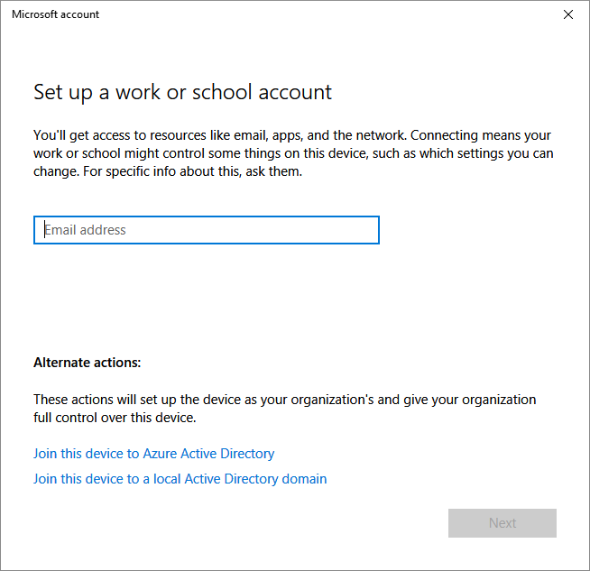

1. On the **Let's get you signed** in dialog, enter your account name (for example, someone@example.com), and then click **Next**.

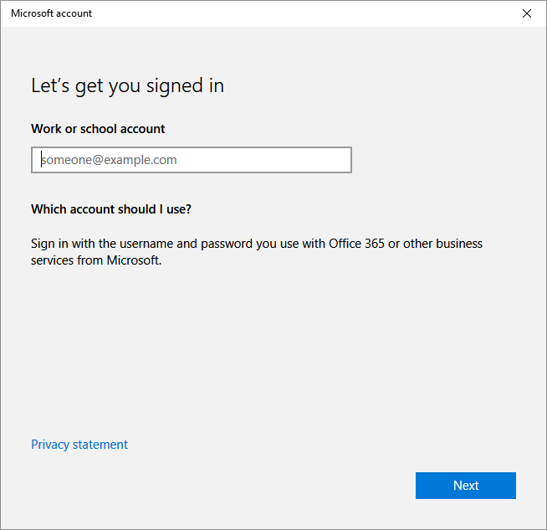

1. On the **Enter password** dialog, enter your password, and then click **Sign in**.

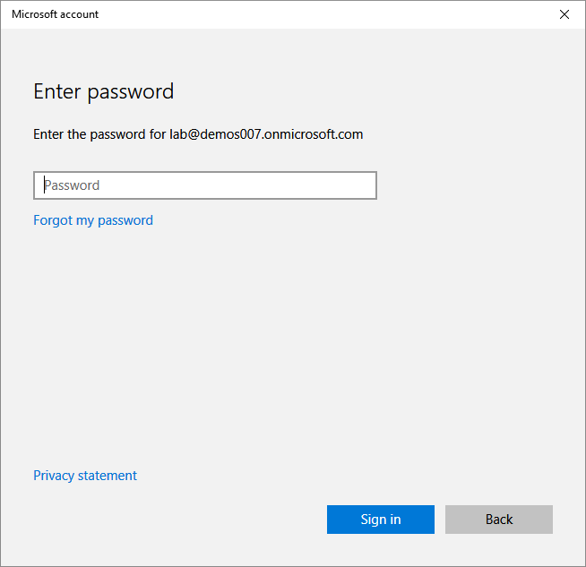

1. On the **Make sure this is your organization** dialog, click **Join**.

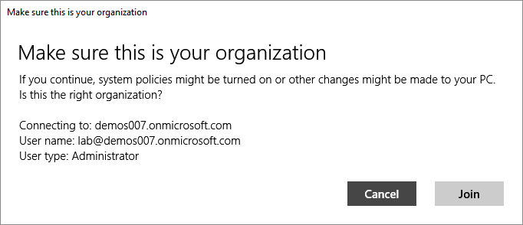

1. After successfully joining your device to Azure AD, your **Access work or school** dialog indicates this with a Connected to <your Azure AD> entry.

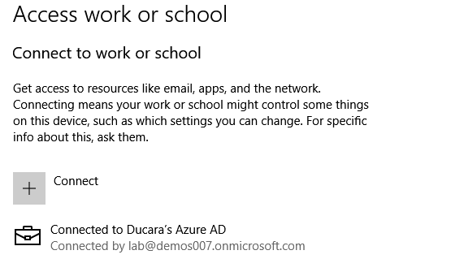

1. And, also after joining, the Azure AD portal will show the detailed overview of registered and joined devices.

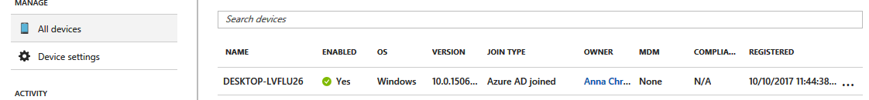

1. So, in this way, you can set up Azure Active Directory joined devices.